|  |  |
| --- | --- |
|  | **YEAR 12 MATHEMATICS SPECIALIST**  **SEMESTER TWO 2016**  **TEST 4: Motion and Differential Equations** |

Name: _______________________

Monday 12th September Time: 50 minutes Mark /45

Section 1 – Calculator free 20 marks

### [5 marks – 4 and 1]

The noise level, in decibels, of the Year 9 class next door is increasing at a rate proportional to the square root of itself, i.e. . The noise level started at 64dB and rose to 100dB in 20 minutes.

1. Write and solve an appropriate differential equation to model this situation
2. How long from the start will it take to exceed the pain threshold by reaching 144 dB?

### [6 marks – 1 each]

A particle is moving in simple harmonic motion with its acceleration at time *t* given by , for *k* a constant.

1. Express each of these quantities in terms of *k*:

##### the period of motion

##### the frequency of motion

##### the amplitude of the motion

##### the displacement

1. If the maximum speed of the particle is 6 units, evaluate:

##### *k*

##### the amplitude

### [3 marks]

An object, with displacement *x* and velocity *v*, moves so that  m/s.

What is the acceleration of this object it is 2 metres from the origin?

### [6 marks – 1, 2 and 3]

* 1. Enter the values of  in this table.

|  |  |  |
| --- | --- | --- |
| *x* | *y* |  |
| 1 | 2 |  |
|  | 3 |  |
| 3 | 0 |  |

* 1. 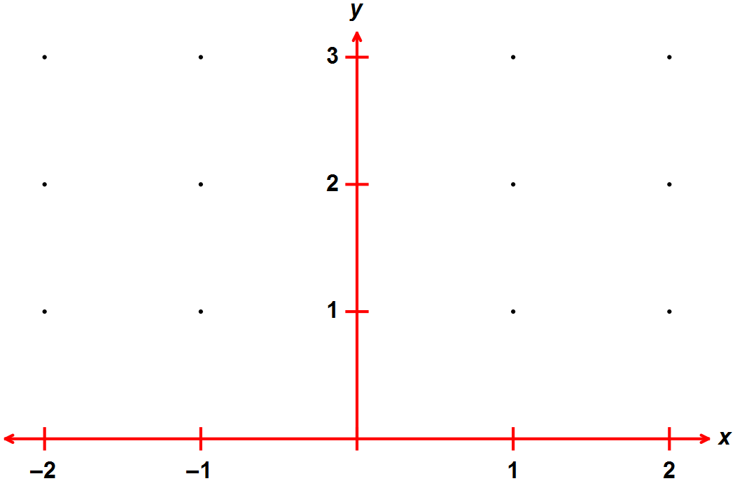Use these values and others from the 20 integer points marked to draw the slope field for the differential equation  .
  2. Solve the differential equation  if *y* = 2 when *x* = 0.

Section 2 – Calculator assumed 25 marks

Name: _______________________

### [3 marks – 2 and 1]

1. Continuing with , complete the table to find the coordinates of the next two points, starting from (2, 1), when the incremental formula (Euler’s method) is applied.

|  |  |  |  |
| --- | --- | --- | --- |
| *x* | *y* |  |  |
| 2 | 1 | 0.1 |  |
|  |  |  |  |
|  |  | - | - |

1. What can be said about the initial (boundary) condition if  and the graph produced using Euler’s method is a horizontal line?

### [3 marks – 2 and 1]

The velocity of particle P1 is given by  while that of P2 is given by .

Both particles are moving along the same straight line and are initially at the origin O.

1. When is the velocity of the two particles the same?
2. What distance is covered by P2 up to and when the velocities are equal?

### [12 marks – 2, 6, 2, 1 and 1]

An advertising executive commissioned a mathematical analysis of the effectiveness of a particular television campaign.

The rate of increase in the percentage of the market (*P*) aware of the product was modelled by  , at *t* weeks

1. This equation has the rate of increase proportional to two basic quantities. What are they?
2. Use appropriate calculus techniques to derive .

If 20% of the market was initially aware of the product, determine:

1. the proportion aware after 2 weeks of advertising
2. how long before 75% of the market is aware
3. the maximum or limiting value of market awareness

PTO for question 8

### [7 marks – 2, 1, 1, 1 and 2]

A steam-driven piston has a displacement, *x*, given by 

1. Show that the piston is in simple harmonic motion.

Determine each of:

1. the amplitude.
2. the first two values of *t*, , when the piston is in its central (mean) position
3. the initial direction of travel
4. the velocity when 